Chapter 7
An Introduction to Linear Programming

1. a, b, and e, are acceptable linear programming relationships.
c is not acceptable because of 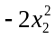
d is not acceptable because of 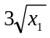
f is not acceptable because of 1x1x2
c, d, and f could not be found in a linear programming model because they have the above nonlinear terms.

3. a.
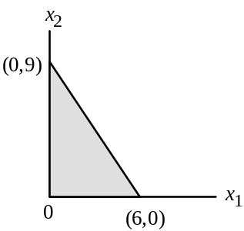

b.
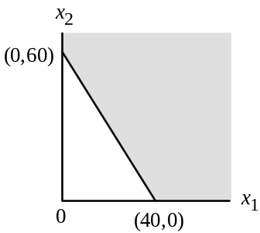

c.

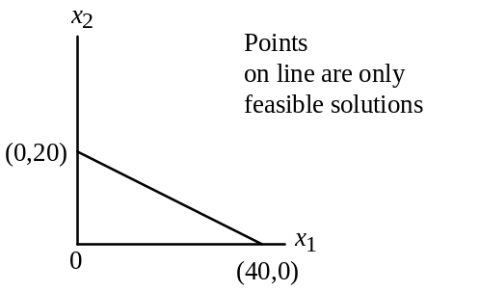

7.
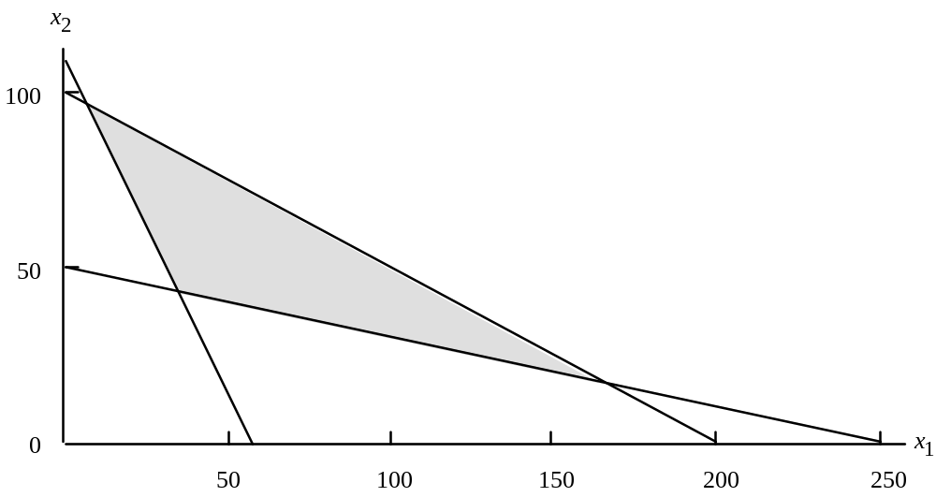

8.
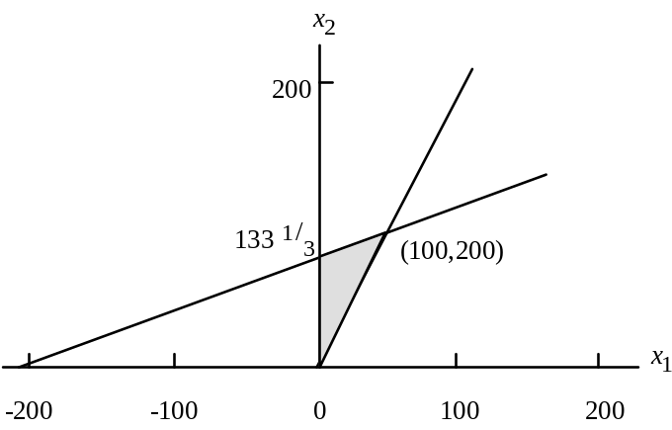

11.

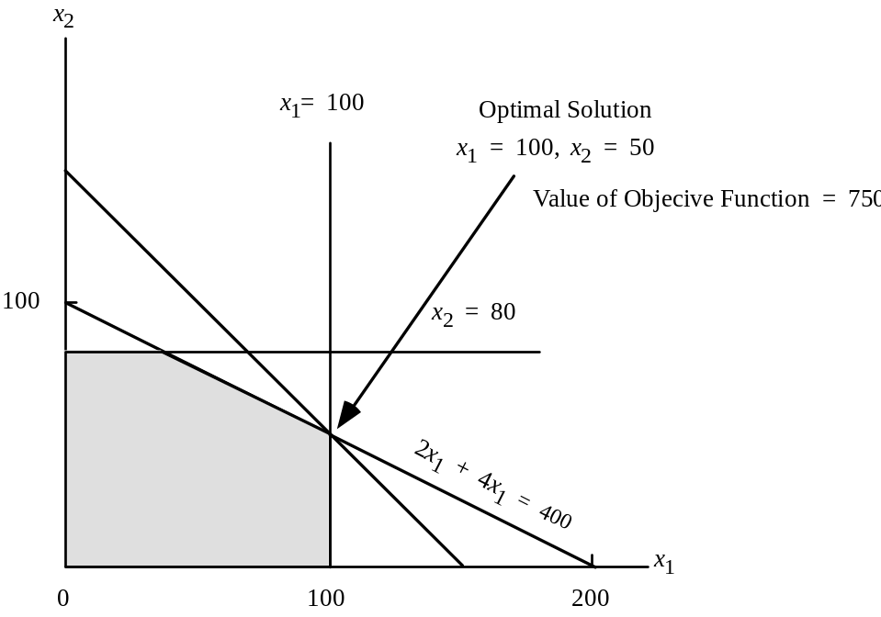

24. a. Let R = number of units of regular model.
C = number of units of catcher’s model.
Max | 5R | + | 8C
s.t.
 | 1R | + | 3/2 C | ≤ | 900 Cutting and sewing
 | 1/2 R | + | 1/3 C | ≤ | 300 Finishing
 | 1/8 R | + | 1/4 C | ≤ | 100 Packing and Shipping
R, C ≥ 0

b.
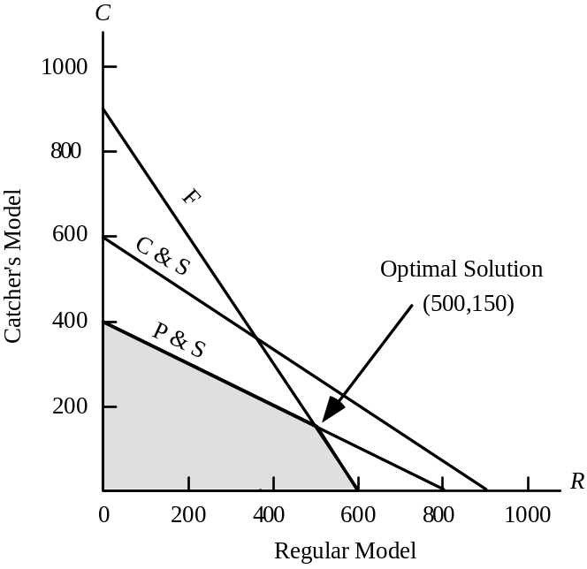
c. 5(500) + 8(150) = $3,700

d. C & S 1(500) + 3/2(150) = 725

F 1/2(500) + 1/3(150) = 300

P & S 1/8(500) + 1/4(150) = 100

e.
Department | Capacity | Usage | Slack
C & S | 900 | 725 | 175 hours
F | 300 | 300 | 0 hours
P & S | 100 | 100 | 0 hours

31.
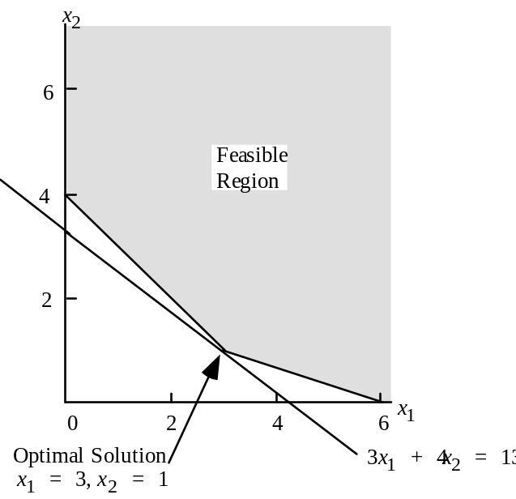

Objective Function Value = 13

